<https://moodle.mmu.ac.uk/pluginfile.php/5340321/mod_resource/content/0/Functions%2C%20Ordering%20and%20Joining%20Slides.pdf>

Extract() - extracts a part from a given date.

## Syntax

EXTRACT(*part* FROM *date*)

These are all the parameters you can have for EXTRACT

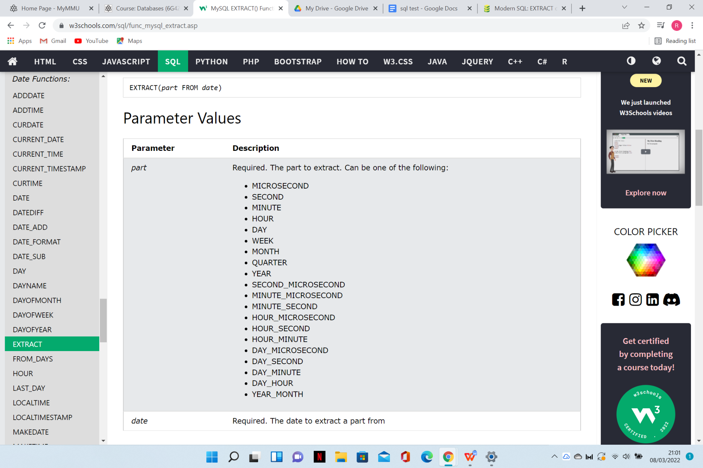

TEST EXAMPLE (SCROLL TOWARDS THE BOTTOM)

<https://www.sqltutorial.org/sql-string-functions/sql-substring/>

LOWER() - The LOWER() function converts a string to lower-case.

## Syntax

LOWER(*text*)

Convert the text in "CustomerName" to lower-case:

SELECT LOWER(CustomerName) AS LowercaseCustomerName

FROM Customers;

**Example-1 :**

Using LOWER() function with Uppercase string.

SELECT LOWER('WAKE UP AND TAKE UP')

As New;

**Output :**

New

wake up and take up

**Example-2 :**

Using LOWER() function with Mixed case string.

SELECT LOWER('EvERy DAy iS A NEW day')

As New;

**Output :**

New

every day is a new day

**Example-3 :**

Using LOWER() function with Select statement. Now, let’s Create Players table and Insert value in it.

Create table Players

(

Firstname varchar(40),

Lastname varchar(40),

Country varchar(40)

)

**Inserting Value :**

Insert into Players values

('VIRAT', 'KOHLI', 'INDIA')

**Output :**

The table will look like this:

| Firstname | Last Name | Country |
| --- | --- | --- |
| VIRAT | KOHLI | INDIA |

**Use of LOWER() function :**

SELECT LOWER(Firstname)

As firstname,

Lastname,

Country

FROM Players;

**Output :**

| firstname | Last Name | Country |
| --- | --- | --- |
| virat | KOHLI | INDIA |

**Example-4 :**

Using LOWER() function in a Variable.

DECLARE @text VARCHAR(45);SET @text = 'LIFE IS AWESOME IF YOU LIVE ';

SELECT @text,

LOWER(@text) AS Lower;

**Output :**

| text value | Lower |
| --- | --- |
| LIFE IS AWESOME IF YOU LIVE | life is awesome if you live |

TEST EXAMPLE(SCROLL TOWARDS BOTTOM)

<https://www.sqltutorial.org/sql-string-functions/sql-lower/>

Length() - The LENGTH() function returns the length of a string (in bytes).

## Syntax

LENGTH(*string*)

### Example

Return the length of the text in the "CustomerName" column, in bytes:

SELECT LENGTH(CustomerName) AS LengthOfName

FROM Customers;

TEST EXAMPLE

<https://www.sqltutorial.org/sql-string-functions/sql-length/>

Round() - rounds a number to a specified number of decimal places.

## Syntax

ROUND(*number*, *decimals*)

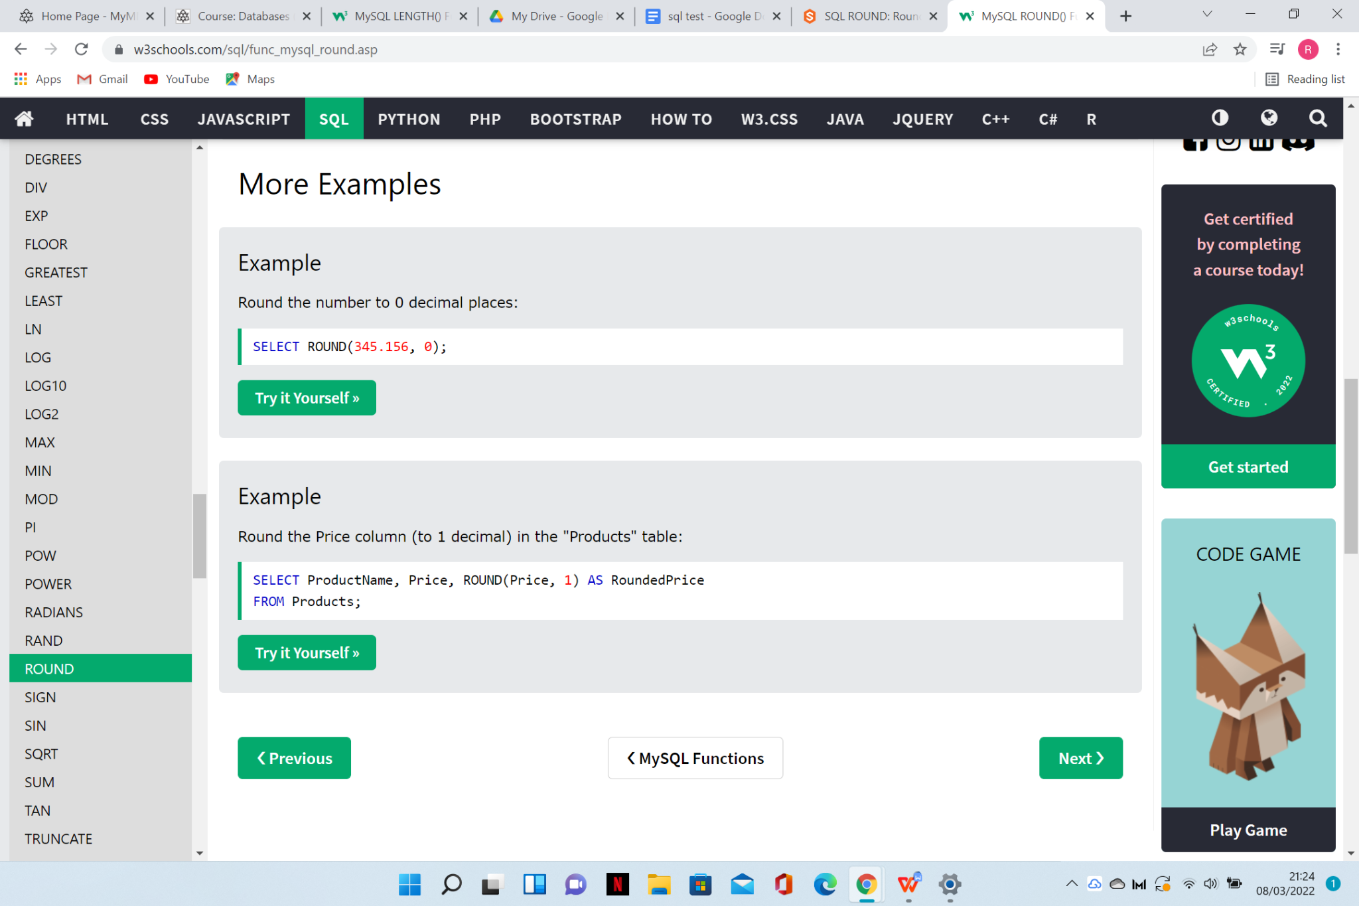

TEST EXAMPLE(SCROLL TOWARDS BOTTOM)

<https://www.sqltutorial.org/sql-math-functions/sql-round/>

Replace() - function replaces all occurrences of a substring within a string, with a new substring. IT IS CASE SENSITIVE

## Syntax

REPLACE(*string*, *from_string*, *new_string*)

## Parameter Values

| **Parameter** | **Description** |
| --- | --- |
| *string* | Required. The original string |
| *from_string* | Required. The substring to be replaced |
| *new_string* | Required. The new replacement substring |

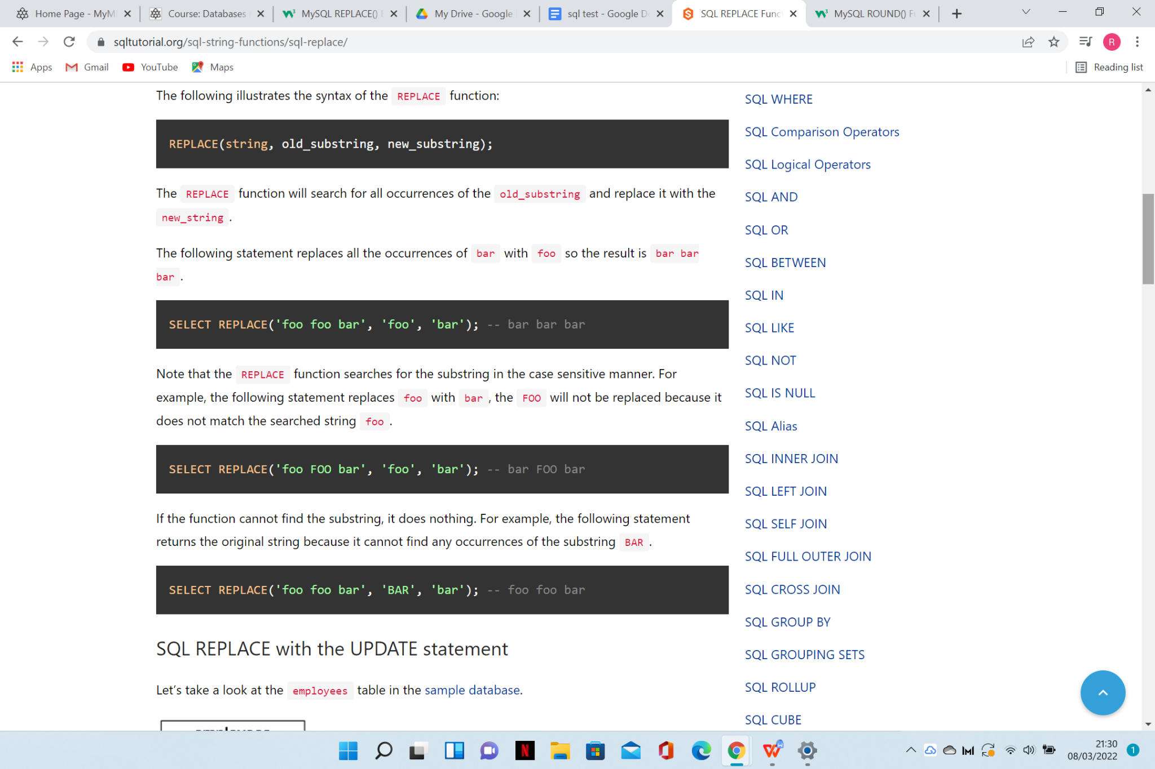

TEST EXAMPLE

<https://www.sqltutorial.org/sql-string-functions/sql-replace/>

Upper() -converts a string to upper-case.

Note: This function is equal to the [UCASE()](https://www.w3schools.com/sql/func_mysql_ucase.asp) function.

## Syntax

UPPER(*text*)

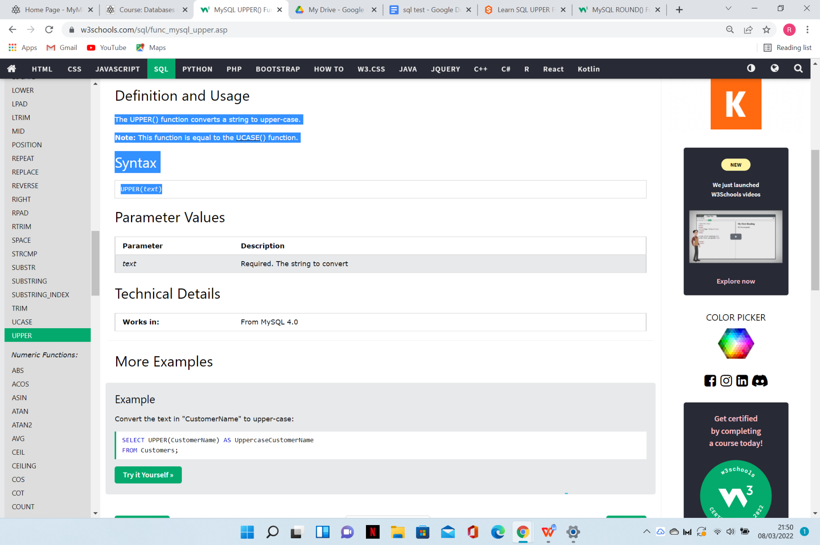

TEST EXAMPLE

<https://www.sqltutorial.org/sql-string-functions/sql-upper/>

SUBSTR()- extracts a substring from a string (starting at any position).

Note: The SUBSTR() and [MID()](https://www.w3schools.com/sql/func_mysql_mid.asp) functions equals to the [SUBSTRING()](https://www.w3schools.com/sql/func_mysql_substring.asp) function.

## Syntax

SUBSTR(*string*, *start*, *length*)

OR:

SUBSTR(*string* FROM *start* FOR *length*)

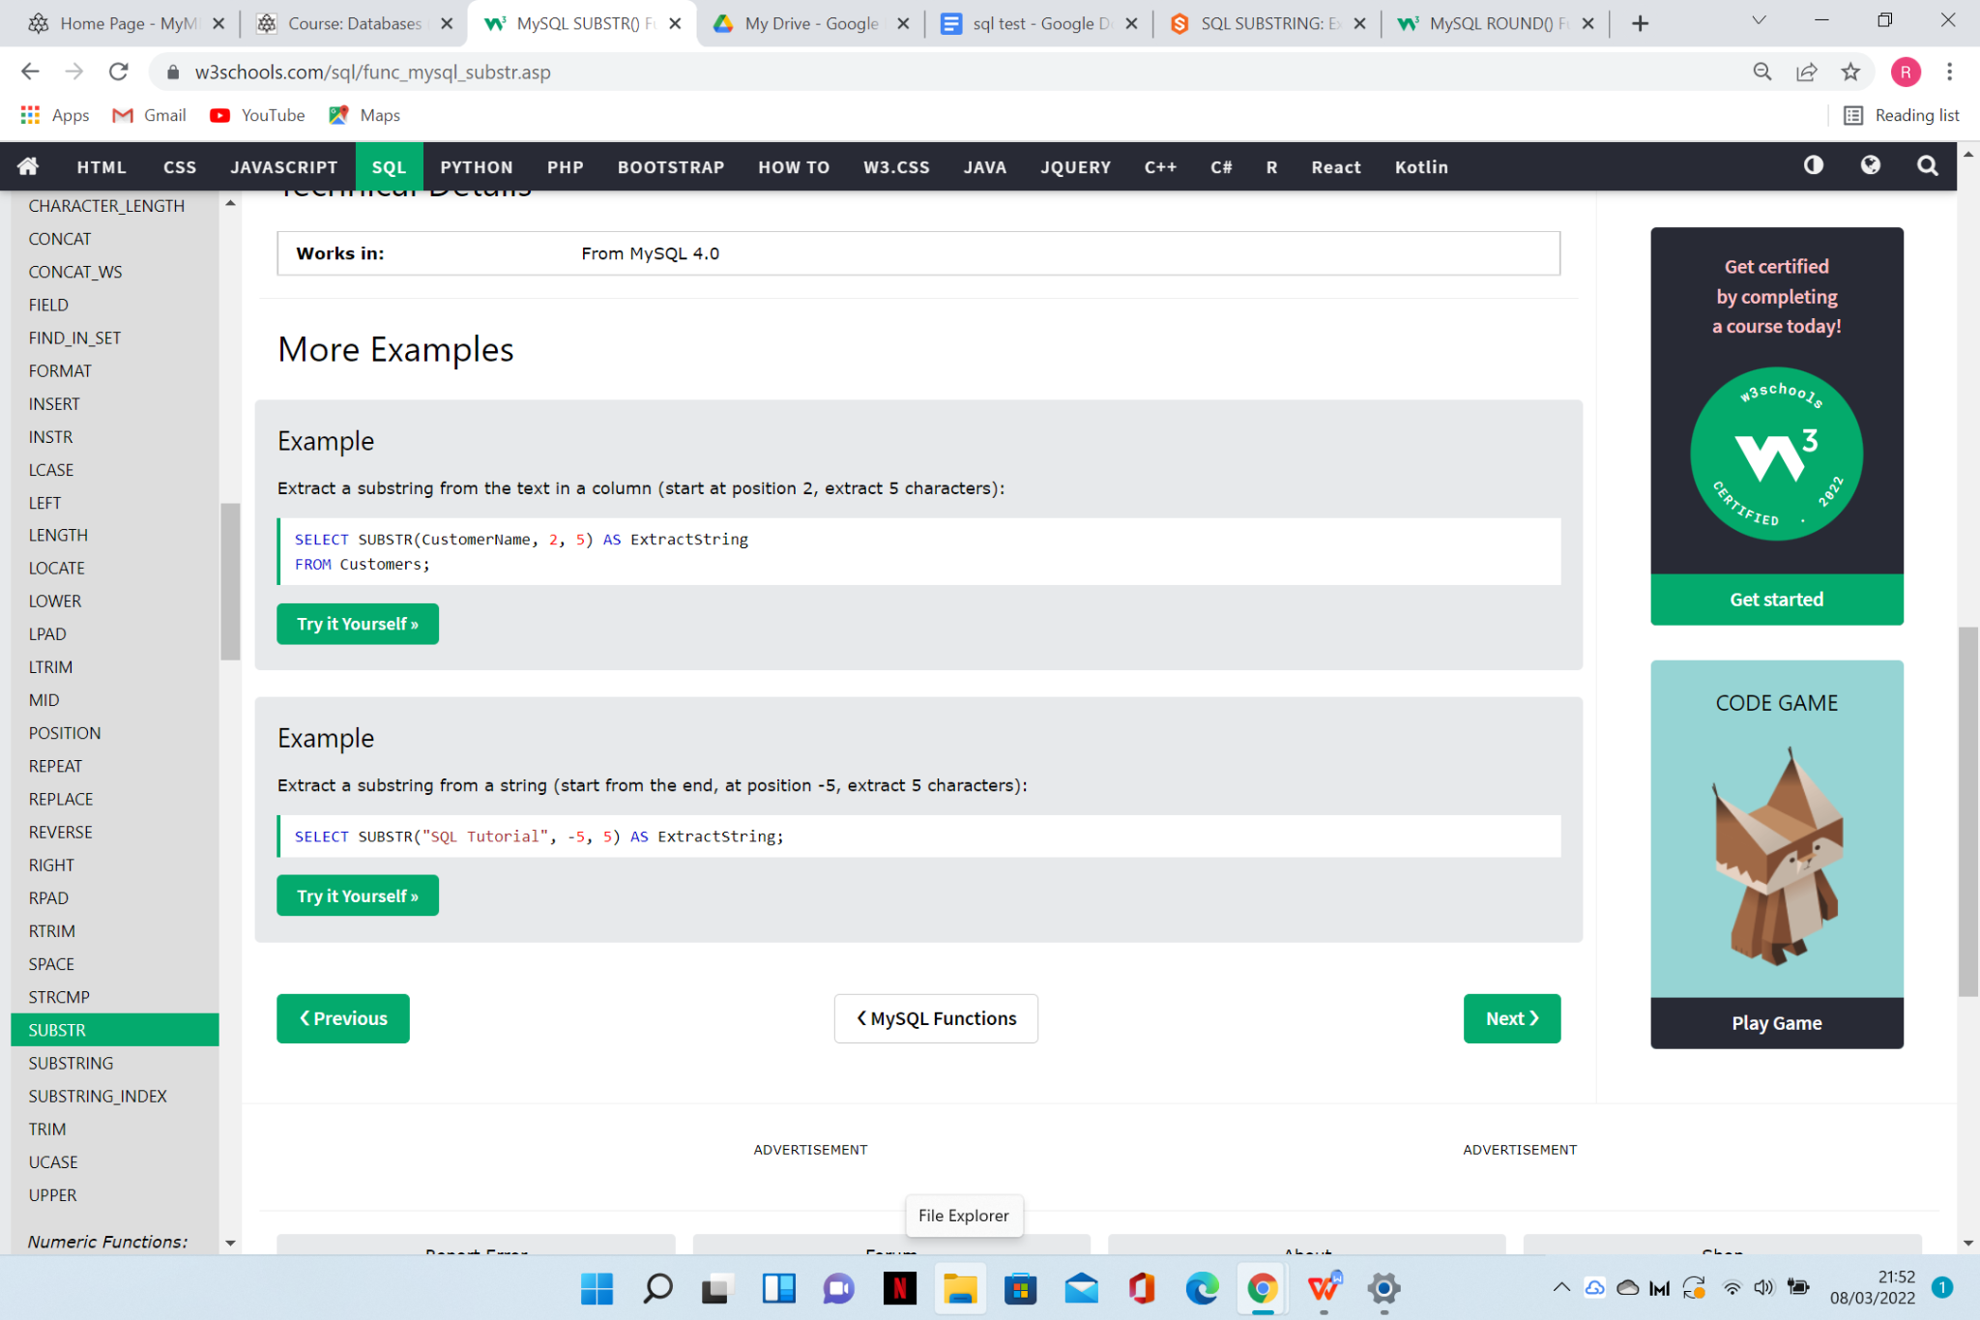

TEST EXAMPLE

<https://www.sqltutorial.org/sql-string-functions/sql-substring/>

CONCAT()- function adds two or more expressions together.

## Syntax

CONCAT(*expression1*, *expression2*, *expression3*,...)

### Example

Add three columns into one "Address" column:

SELECT CONCAT(Address, " ", PostalCode, " ", City) AS Address

FROM Customers;

TEST EXAMPLE

<https://www.sqltutorial.org/sql-string-functions/sql-concat/>

TIMESTAMPDIFF

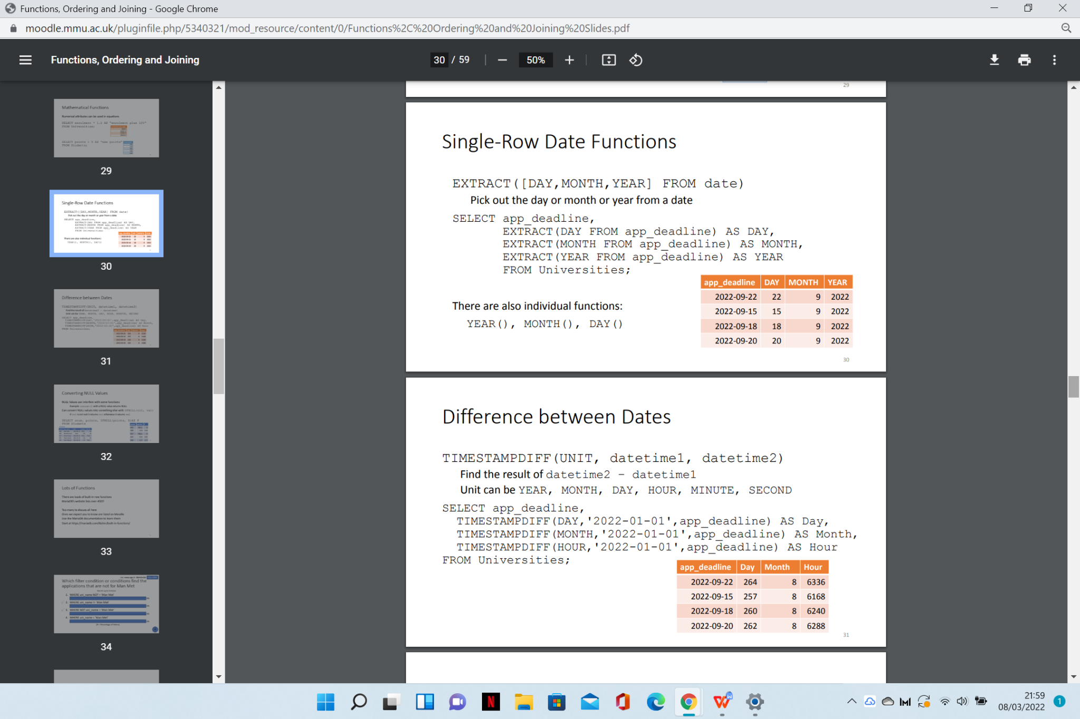

IF NULL() -returns a specified value if the expression is NULL.

If the expression is NOT NULL, this function returns the expression.

## Syntax

IFNULL(*expression*, *alt_value*)

### Example

Return the specified value IF the expression is NULL, otherwise return the expression:

SELECT IFNULL("Hello", "W3Schools.com");

TEST EXAMPLE

<https://www.sqltutorial.org/sql-comparison-functions/sql-nullif/>

CHAR_LENGTH - The CHAR_LENGTH() function return the length of a string (in characters).

Note: This function is equal to the [CHARACTER_LENGTH()](https://www.w3schools.com/sql/func_mysql_character_length.asp) function.

### Example

Return the length of the text in the "CustomerName" column:

SELECT CHAR_LENGTH(CustomerName) AS LengthOfName

FROM Customers;

TEST EXAMPLE

CUR_DATE -returns the current date.

Note: The date is returned as "YYYY-MM-DD" (string) or as YYYYMMDD (numeric).

Note: This function equals the [CURRENT_DATE()](https://www.w3schools.com/sql/func_mysql_current_date.asp) function.

## Syntax

CURDATE()

Return the current date + 1:

SELECT CURDATE() + 1;

TEST EXAMPLE

<https://www.sqltutorial.org/sql-date-functions/sql-current-date/>

MONTH - returns the month part for a given date (a number from 1 to 12).

## Syntax

MONTH(*date*)

### Example

Return the month part of a date:

SELECT MONTH("2017-06-15 09:34:21");

TEST EXAMPLE

<https://www.sqltutorial.org/sql-date-functions/how-to-extract-month-from-date-in-sql/>

HOUR

SELECT HOUR("2017-06-20 09:34:00");

MINUTE

SELECT MINUTE("2017-06-20 09:34:00");

SECOND

SELECT SECOND("2017-06-20 09:34:00.000023");

DAY <https://www.sqltutorial.org/sql-date-functions/how-to-extract-day-from-date-in-sql/>

SELECT DAY("2017-06-15");

YEAR <https://www.sqltutorial.org/sql-date-functions/how-to-extract-day-from-date-in-sql/>

SELECT YEAR("2017-06-15");

AVG – returns the average value of an expression.

Note: NULL values are ignored.

## Syntax

AVG(*expression*)

### Example

### Select the records that have a price above the average price:SELECT * FROM ProductWHERE Price > (SELECT AVG(Price) FROM Products);

TEST EXAMPLE

<https://www.sqltutorial.org/sql-aggregate-functions/sql-avg/>

COUNT -The COUNT() function returns the number of records returned by a select query.

Note: NULL values are not counted.

## Syntax

COUNT(*expression*)

Example

Return the number of products in the "Products" table:

SELECT COUNT(ProductID) AS NumberOfProducts FROM Products;

TEST EXAMPLE

<https://www.sqltutorial.org/sql-aggregate-functions/sql-count/>

MAX- The MAX() function returns the maximum value in a set of values.

## Syntax

MAX(*expression*)

### Example

Find the price of the most expensive product in the "Products" table:

SELECT MAX(Price) AS LargestPrice FROM Products;

TEST EXAMPLE

<https://www.sqltutorial.org/sql-aggregate-functions/sql-max/>

MIN - Returns the minimum value in a set of values.

## Syntax

MIN(*expression*)

TEST EXAMPLE

<https://www.sqltutorial.org/sql-aggregate-functions/sql-min/>

SUM - Definition and Usage

The SUM() function calculates the sum of a set of values.

Note: NULL values are ignored.

## Syntax

SUM(*expression*)

### Example

Return the sum of the "Quantity" field in the "OrderDetails" table:

SELECT SUM(Quantity) AS TotalItemsOrdered FROM OrderDetails;

TEST EXAMPLE

<https://www.sqltutorial.org/sql-aggregate-functions/sql-sum/>

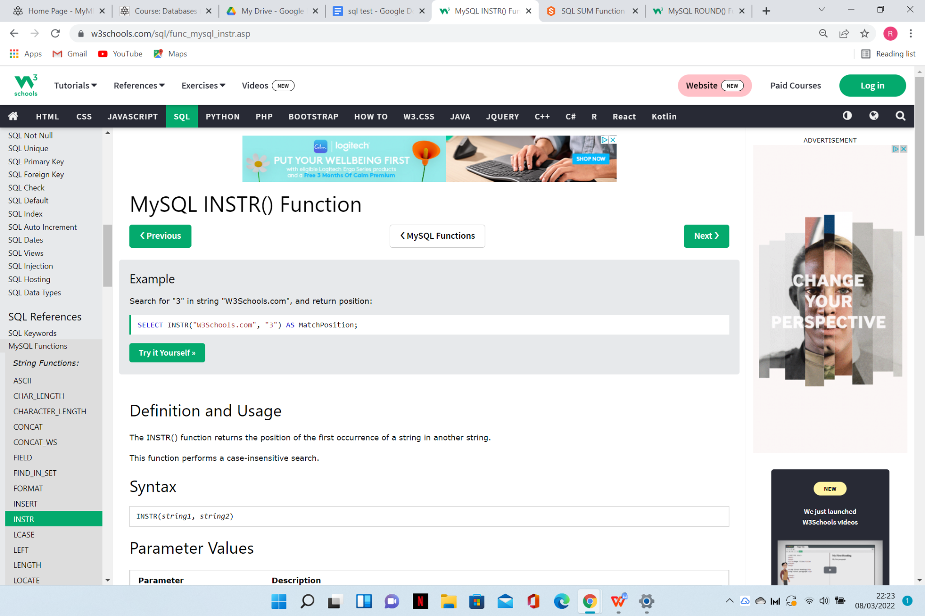

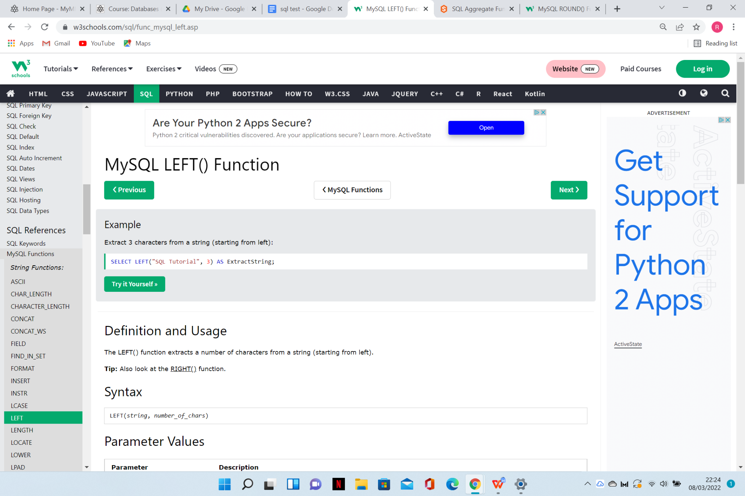

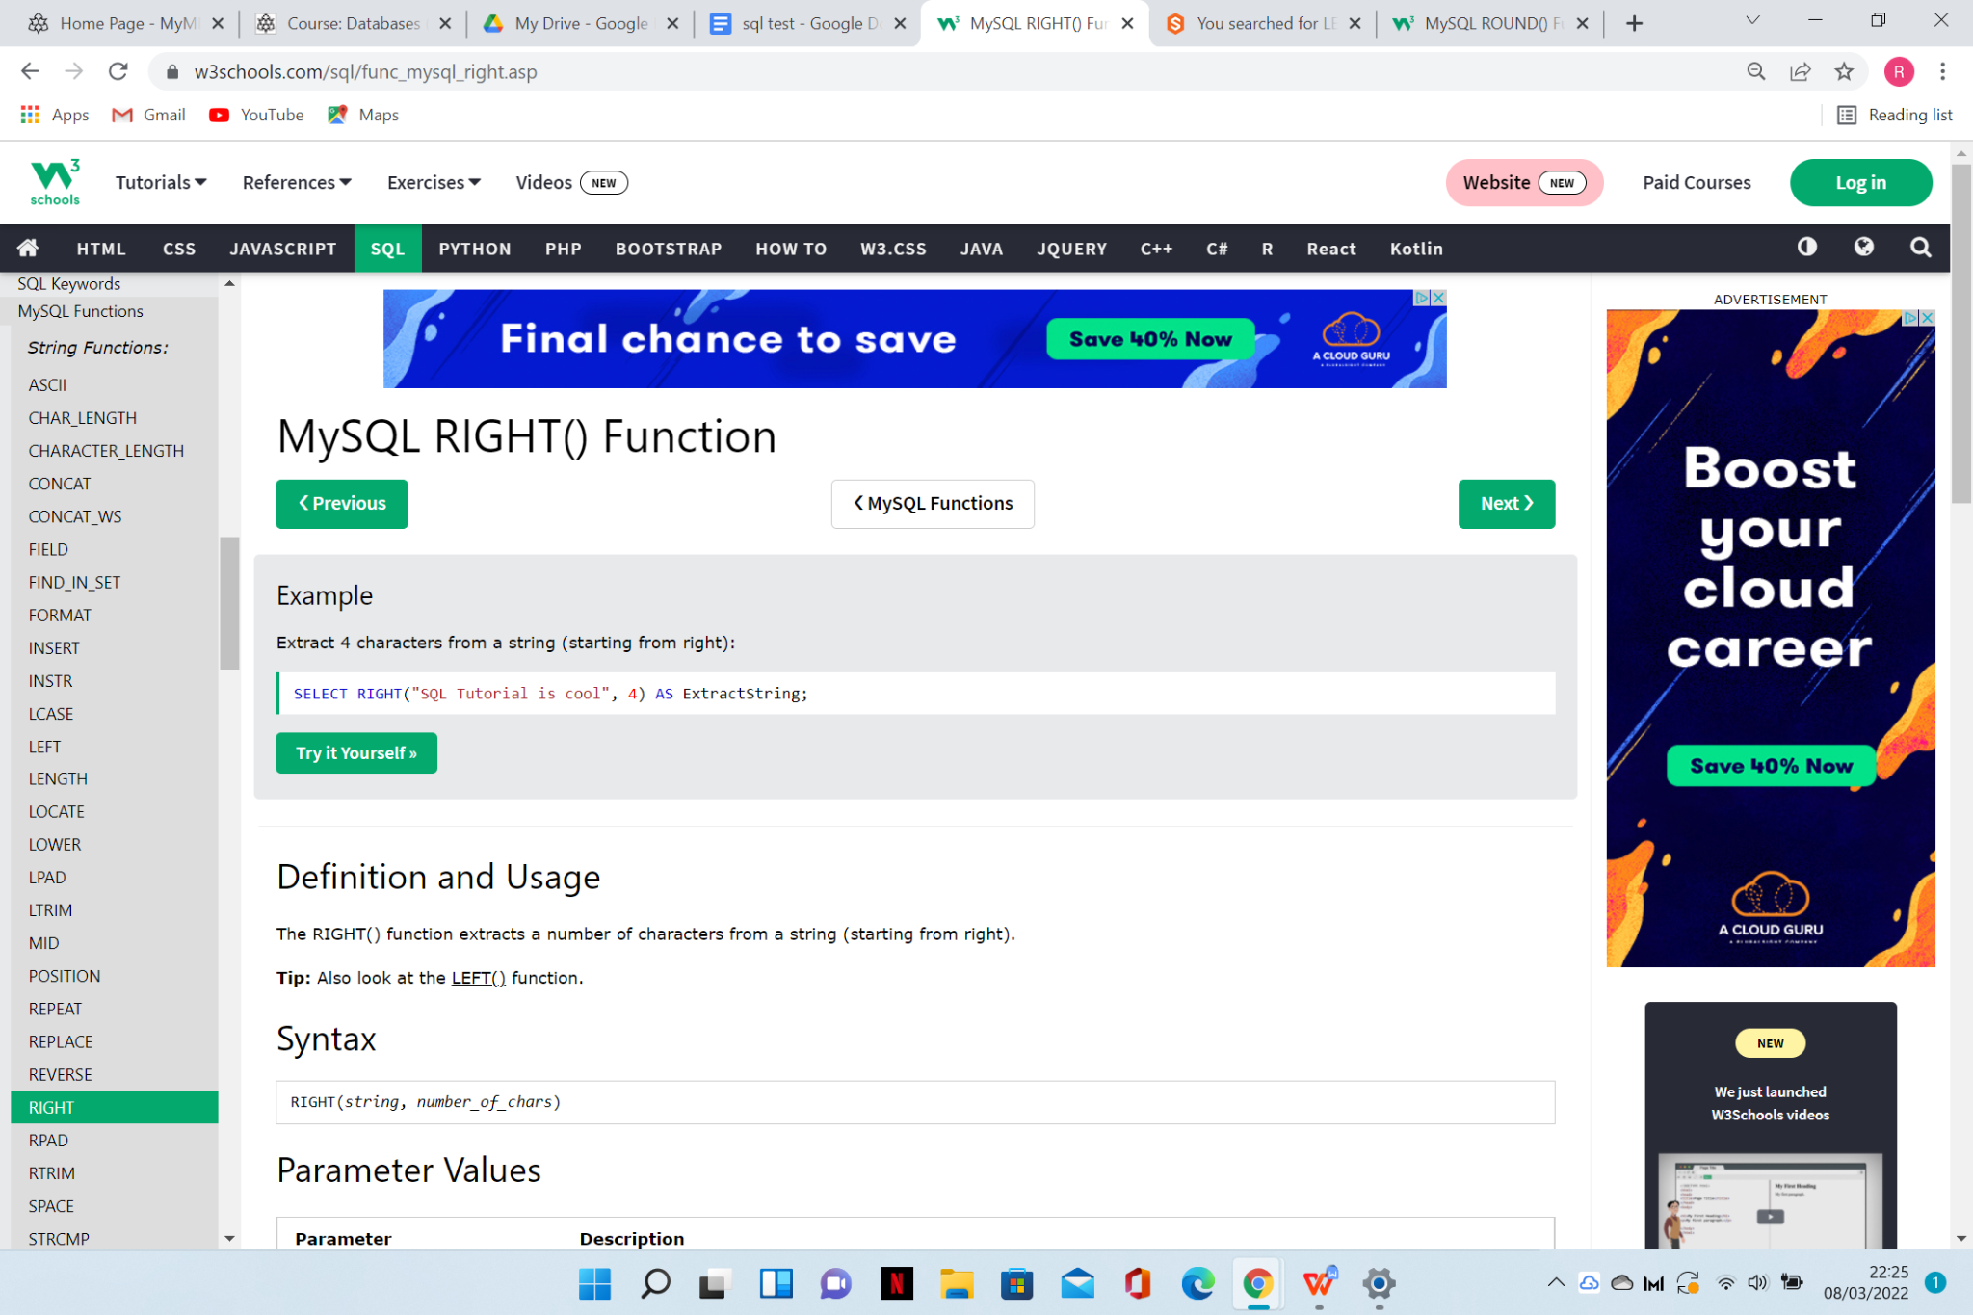

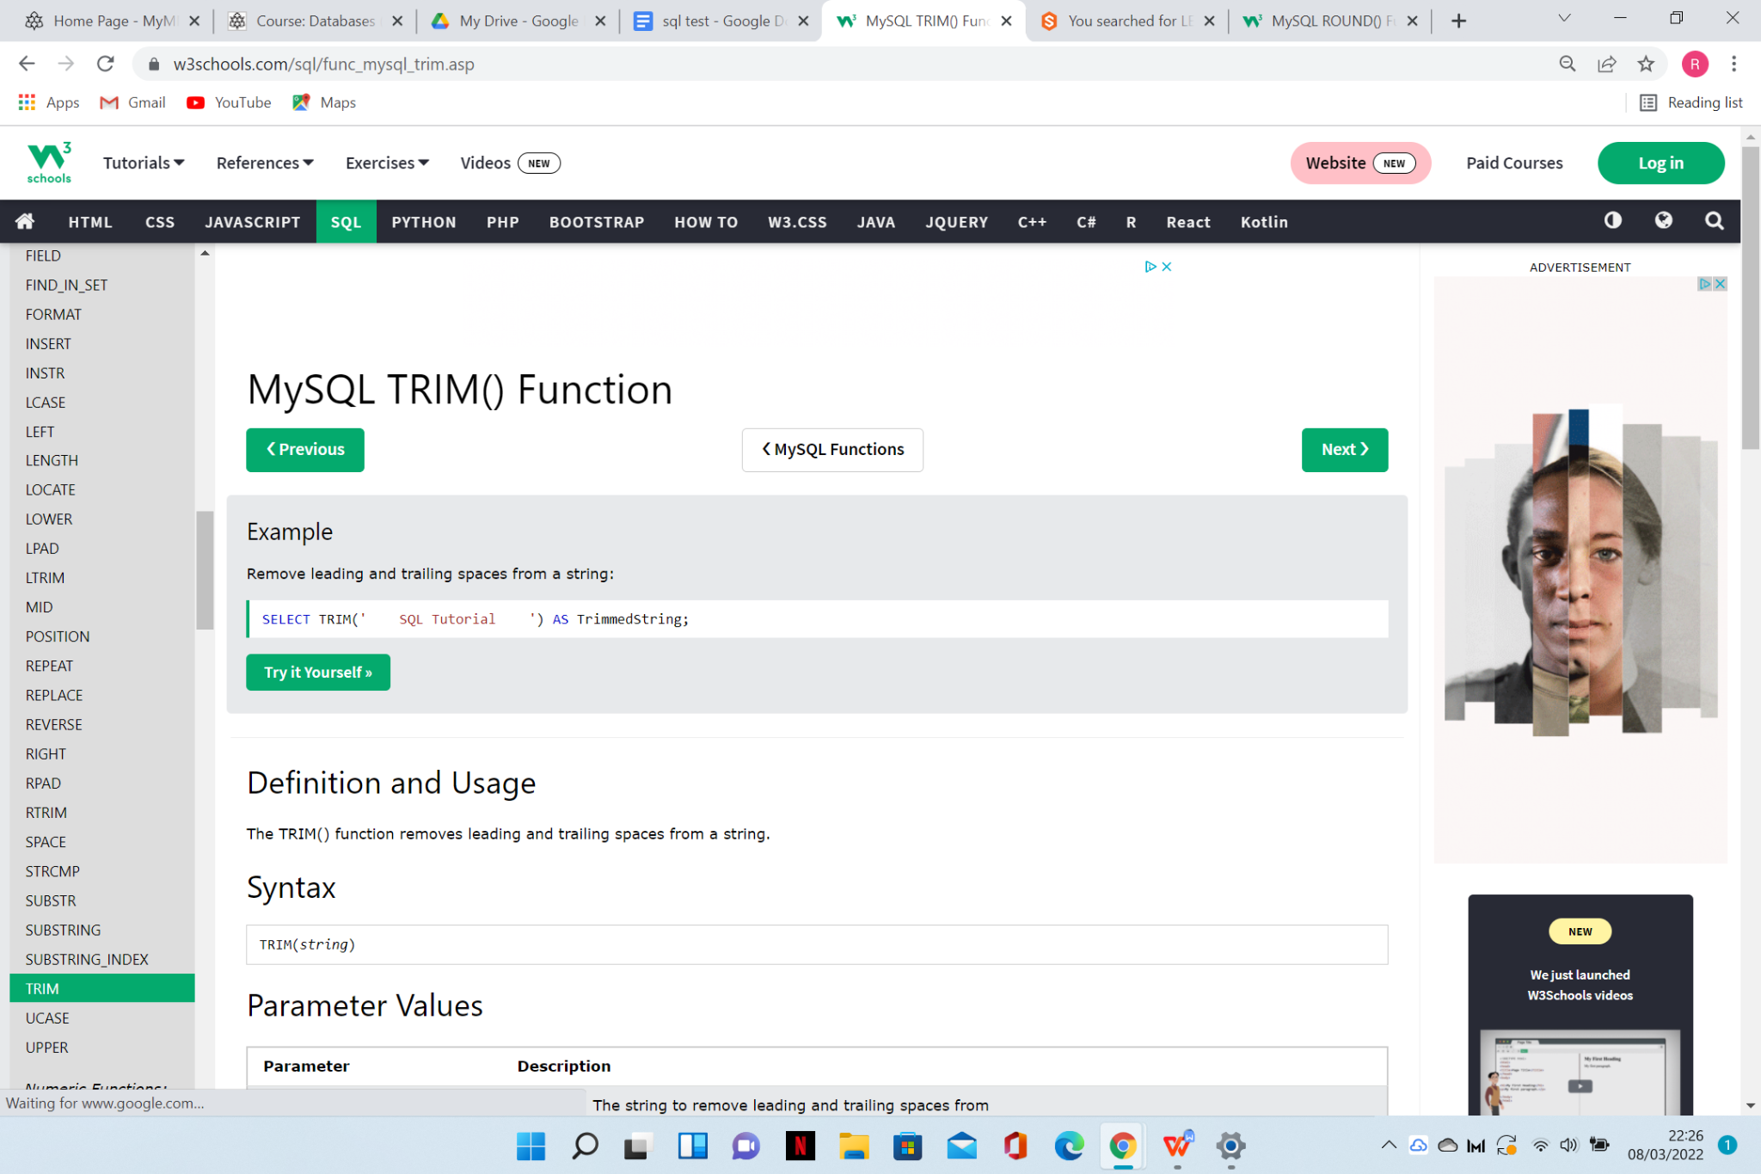

TEST EXAMPLE

<https://www.sqltutorial.org/sql-string-functions/sql-trim/>

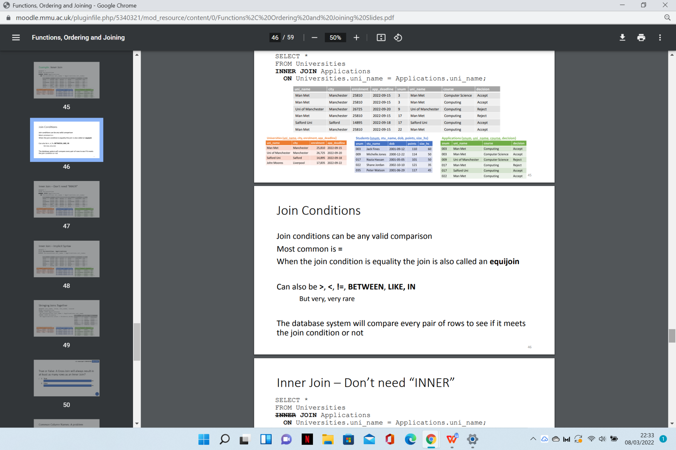

INNER JOIN

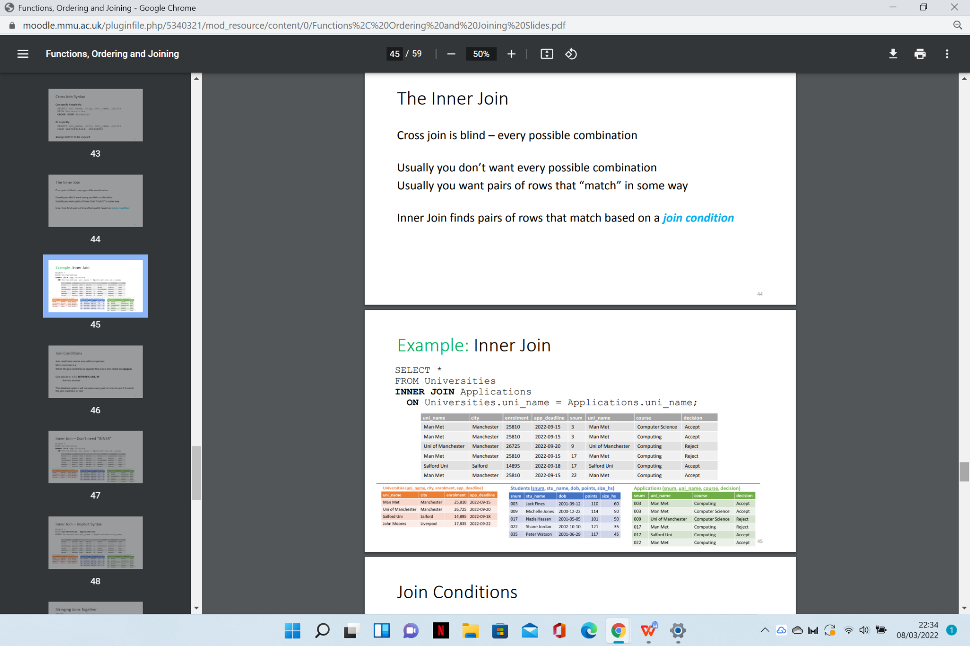

TEST EXAMPLE

<https://www.sqltutorial.org/sql-inner-join/>

CROSS JOIN

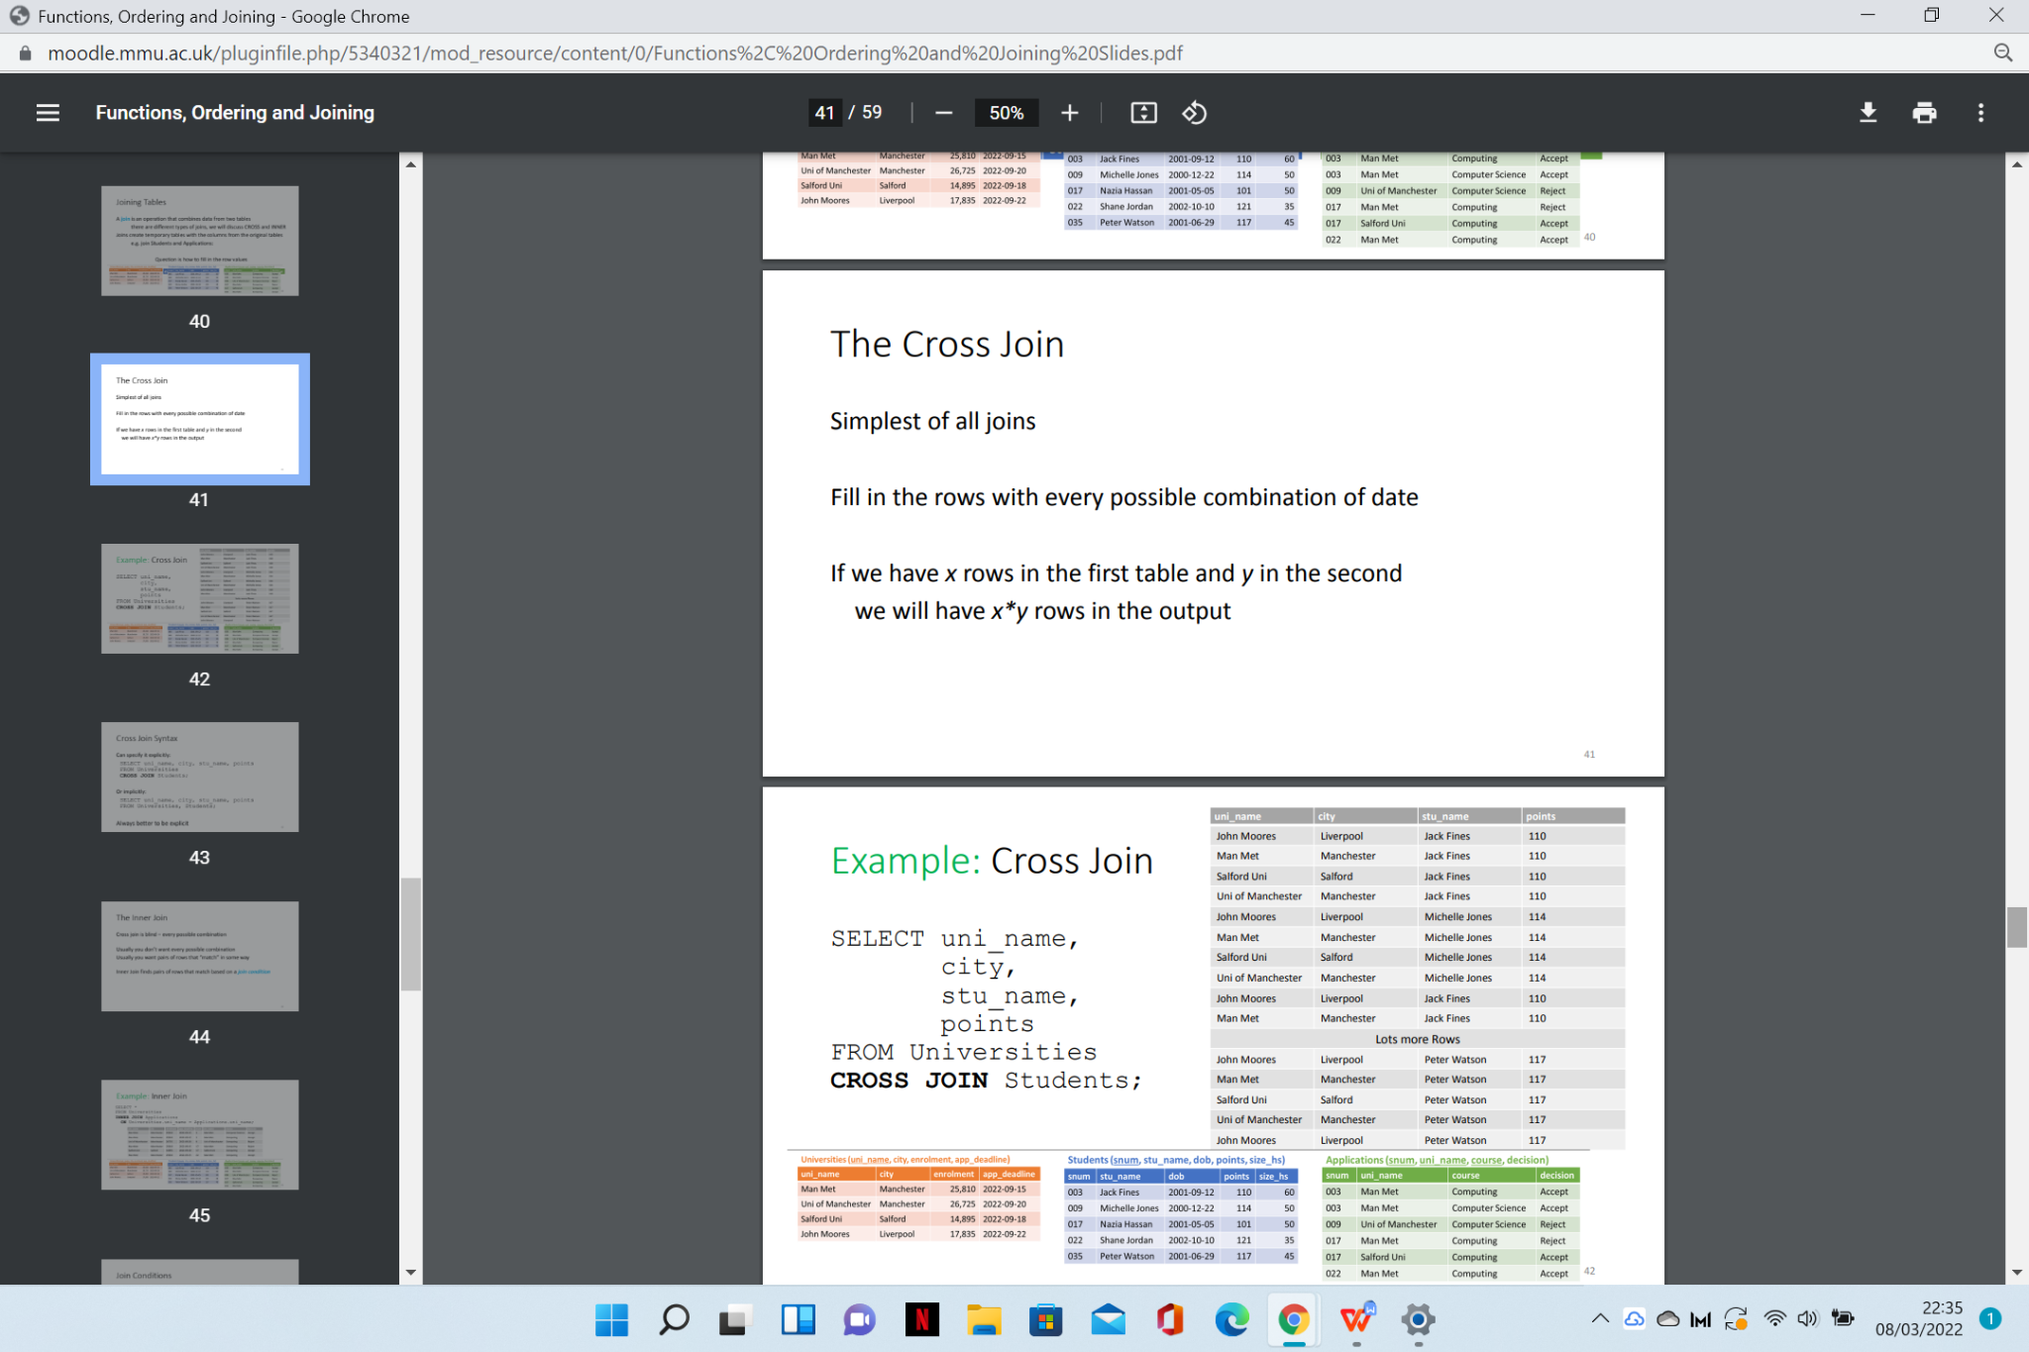

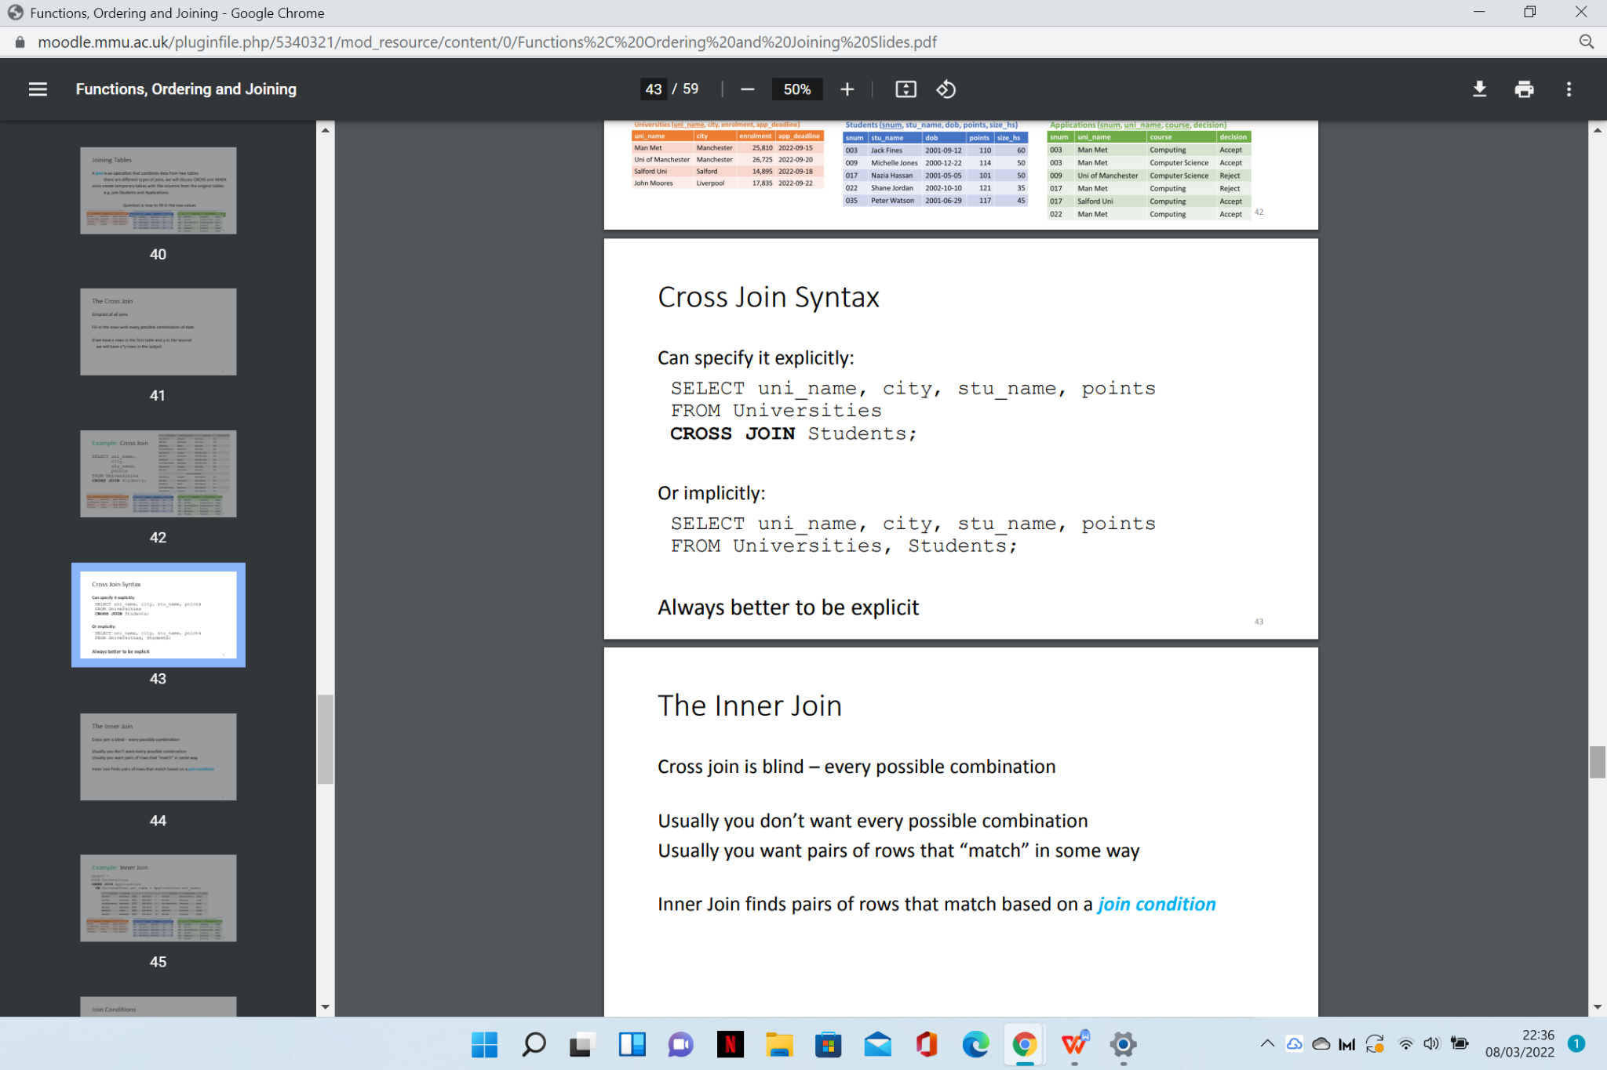

TEST EXAMPLE

<https://www.sqltutorial.org/sql-cross-join/>

LEFT JOIN

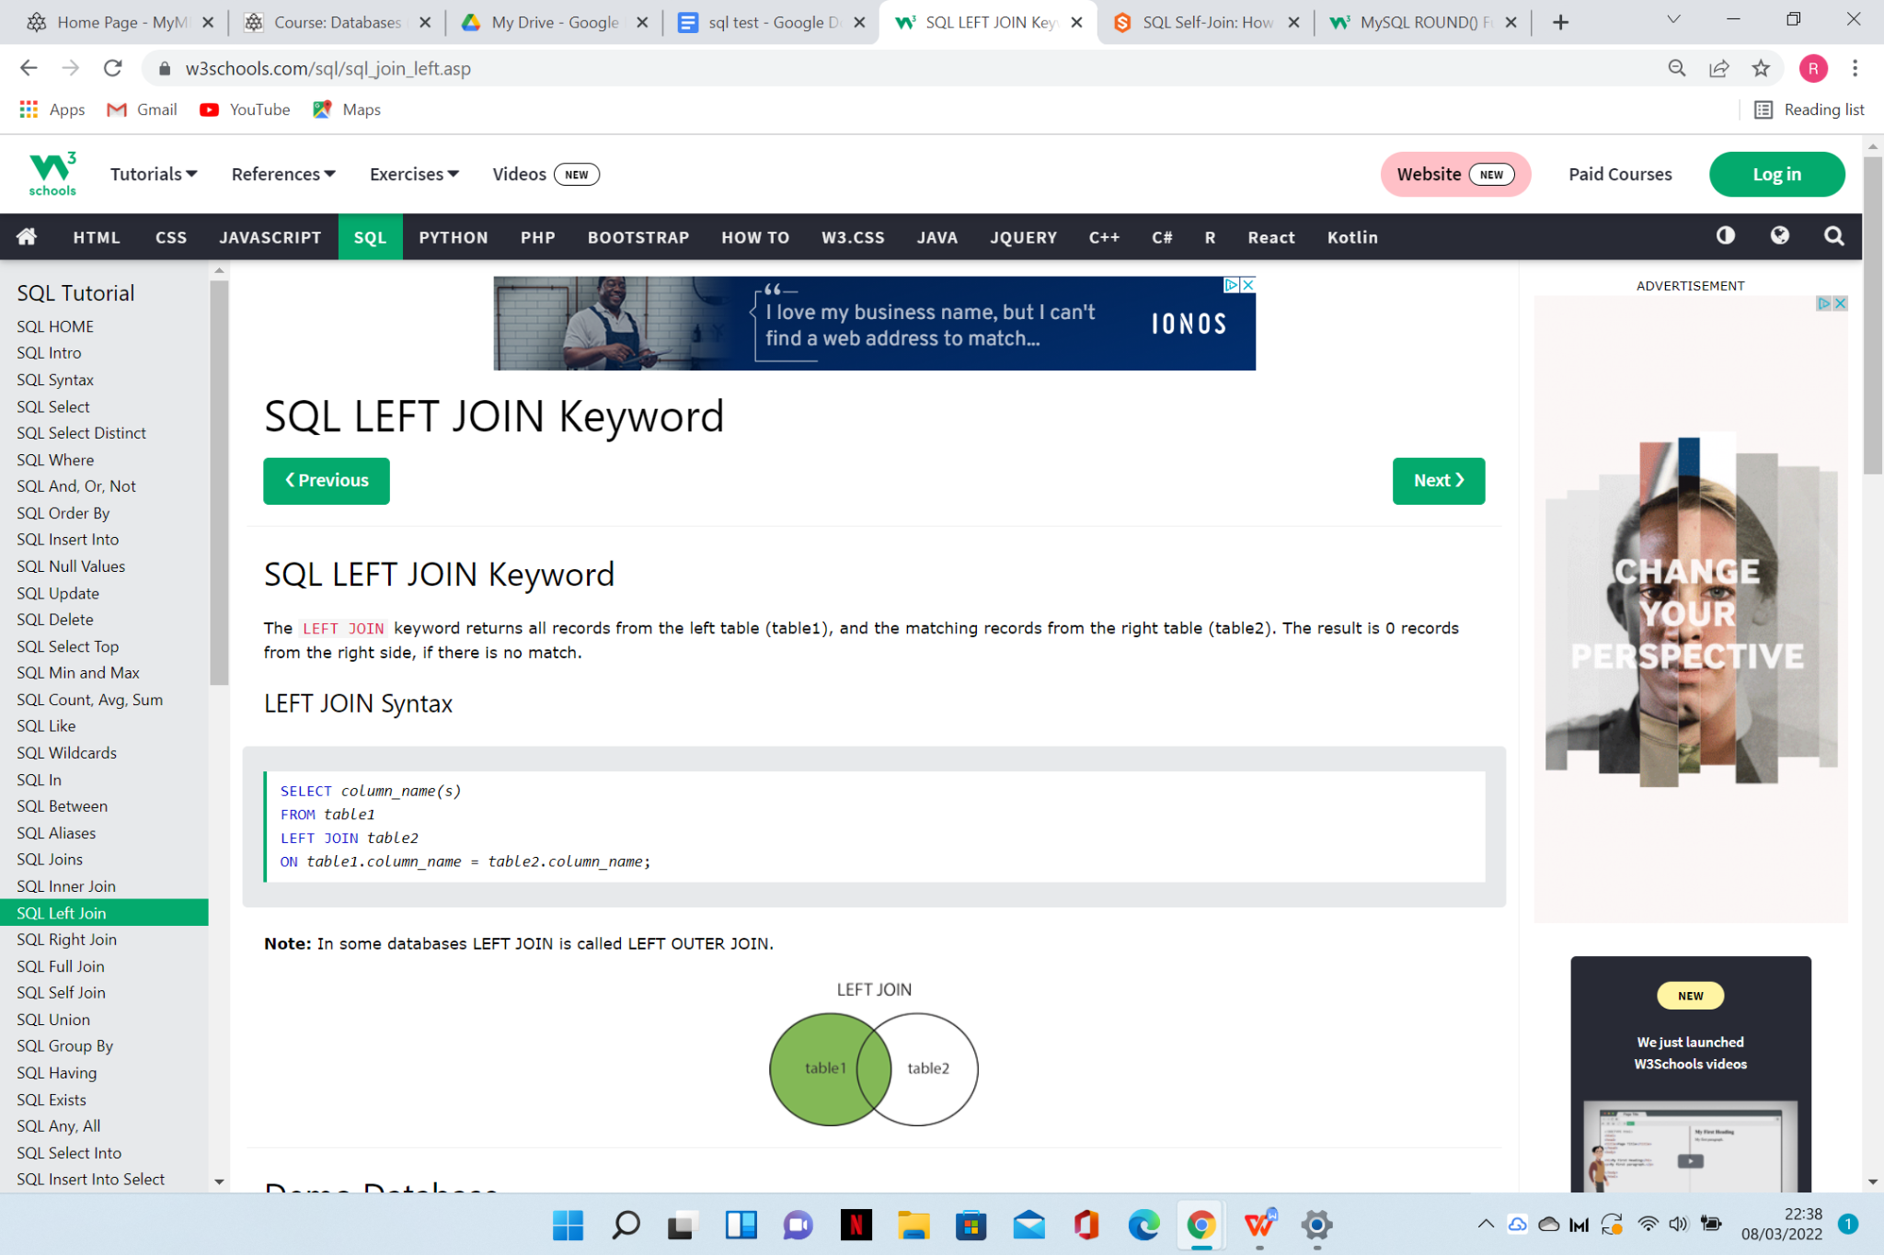

TEST EXAMPLE

<https://www.sqltutorial.org/sql-left-join/>

OUTER JOIN

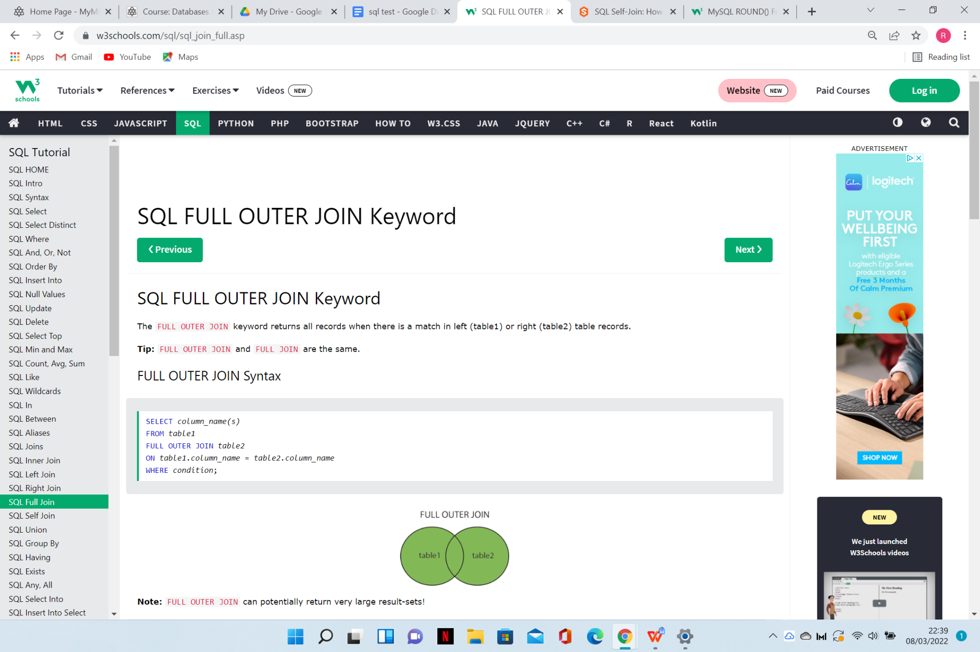

TEST EXAMPLE

<https://www.sqltutorial.org/sql-full-outer-join/>

SELF JOIN

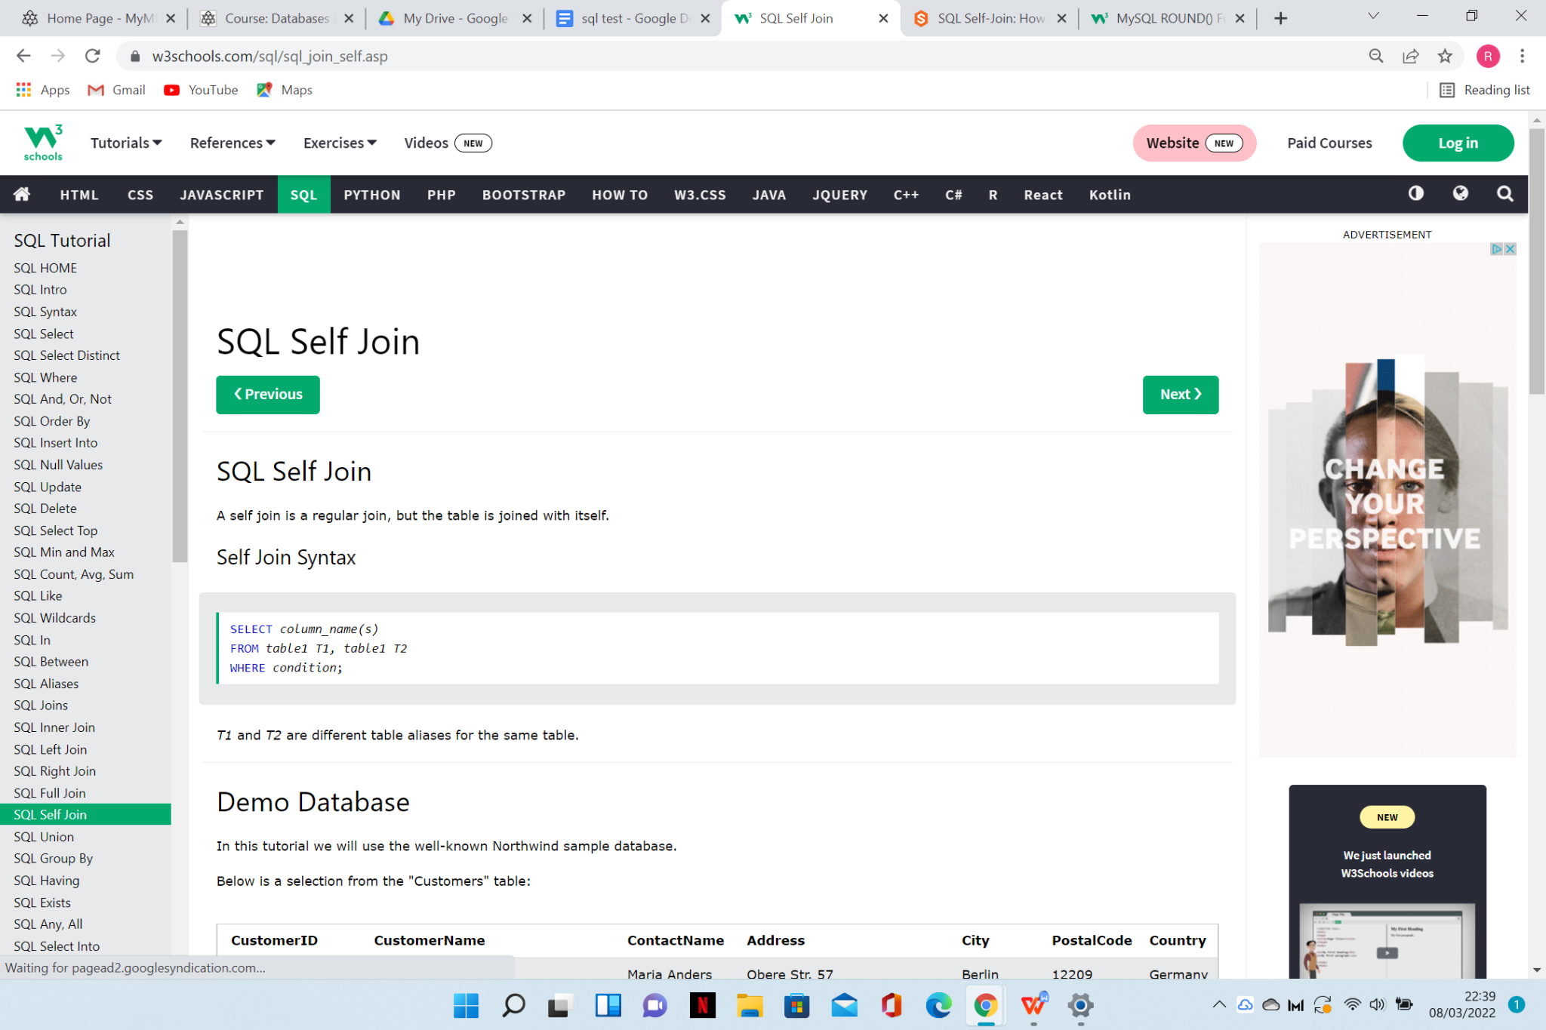

TEST EXAMPLE

<https://www.sqltutorial.org/sql-self-join/>

NATURAL JOIN

